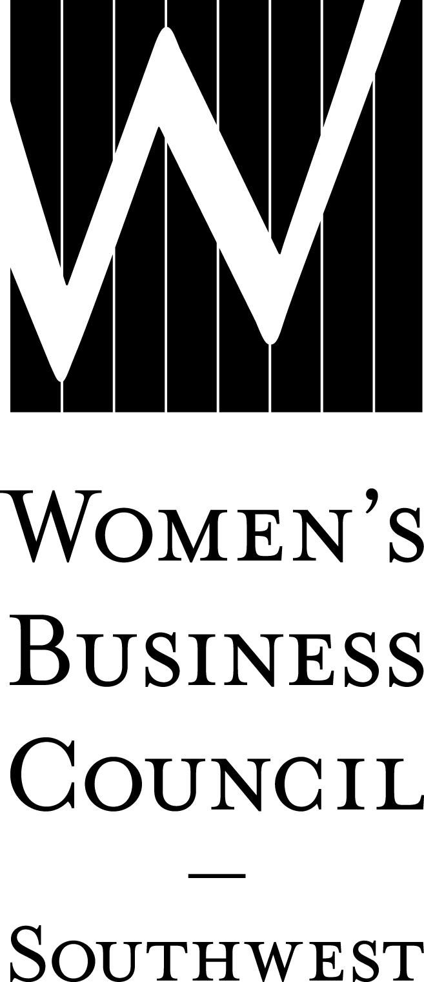2018 WBE Bundle / Early Commitment Worksheet Date:
Company:
Contact:
Phone: ( )
Email:

Secure your 2018 sponsorships by submitting this worksheet to the Council by December 15, 2017,
and remit payment by February 1, 2018 to receive your 15% discount.

I. MAJOR EVENTS Price Cost
Parade of Stars Awards Gala
February 1, 2018
Cocktail Reception – 1 @ $6,000 $
Program Book – 1 @ $6,000 $
After Party – 1 @ $4,000 $
Diamond $2,000 $
Emerald $ 750 $
Ruby $ 500 $
Table of 8 $1,000 $

Power to Potential
April 17, 2018
Title – 1 @ $3,500 SOLD OUT Power Lunch – 1 @ $2,500 $
Procurement Roundtable Sessions – 1 @ $2,500 SOLD OUT
Networking Reception – 1 @ $2,000 SOLD OUT Diamond $ 600 $
Emerald $ 400 $

Business Works Expo
September 2018
Title – 1 @ $5,000 SOLD OUT
Kick-Off Luncheon – 1 @ $4,000 $
Networking Reception – 2 @ $3,500 SOLD OUT
Connections Café – 1 @ $3,000 $
Directory – 1 @ $3,000 SOLD OUT
Matchmaker – 1 of 2 @ $2,500 $
Silent Auction – 1 of 2 @ $2,000 $
Upgrade Exhibitor $ 400 $
Basic Exhibitor $ 300 $

Harvesting Partnerships Educational Symposium
November 2018
Title – 1 @ $4,000 SOLD OUT
Lillie Knox Memorial Luncheon – 1 @ $3,000 $
Networking Reception – 1 @ $2,000 SOLD OUT Diamond $ 750 $
Emerald $ 400 $

II. EDUCATIONAL PROGRAMMING SPONSORSHIP OPPORTUNITIES Price Cost
Dallas/Fort Worth
Table Topics Luncheons (February-November 2018)
Diamond $1,000 $

Ladies Who Launch (May 2018)
Title – 1 @ $1,000 $
Diamond $ 500 $

Executive Insights (July 2018)
Diamond $ 500 $

Austin
Woman Entrepreneur’s Exchange (January & July 2018)
Diamond $ 500 $

Winning the Bid (April 2018)
Title – 1 @ $ 500 SOLD OUT

Austin Insights (September 2018)
Title – 1 @ $1,000 SOLD OUT Diamond $ 500 $
Emerald $ 300 $

Arkansas, El Paso, New Mexico and Oklahoma
Regional Events
Diamond Location: $ 500 $

III. LILLIE KNOX INVESTING FOR GROWTH GRANT
Underwriter Donor $ 500 $
Distinctive Donor $ 250 $
Other Amount $

Sponsorship Total = $
IV. APPLY 15% SPONSORSHIP BUNDLE DISCOUNT
Sponsorship total must be at least $1,000. - $
V. FINAL TOTAL must be received by February 1, 2018 = $

